Breakfast
Read: 1 John 4:7-12
Focus: I John 4:8
Think: Love in essence
I remember the text ‘God is love’ as a framed embroidery in my grandmother’s house and I imagine some people have similar memories of it. Most could quote it, not all could find it in the bible. Yet, it tells us one of the most fundamental things we can know about God that he is in his very essence the personification of love. Love motivates, shapes and undergirds everything he does in relation to us. All God’s acts are loving acts, even in judgement. ‘Far from condoning sin his love has found a way to expose it and consume it without destroying the sinner, but rather saving him.’ (John R W Stott)
Song: Loved with everlasting love, led by grace that love to know; Spirit breathing from above You have taught me it is so: O what full and perfect peace, joy and wonder all divine! In a love which cannot cease, I am His and He is mine.
George Wade Robinson.
Prayer: Beautiful Saviour, what can I offer you for the lavish gift of your love? I joyfully offer you my life, my worship, my treasure, my time and a willing delight to do every kind of good. Amen.
Seeking God’s Face. Philip F. Reinders
Lunch
Read: 1 John 4:7-12
Focus: 1 John 4:10
Think: Love in action
Have you ever though how difficult it is to take the first step towards reconciliation. Maybe it’s more personal than simply an idea and you’ve been challenged to actually do it. How did it go? The truth is when there’s personal hurt, or wounded pride involved there’s a lot at stake and we often bottle it preferring to live in a deep freeze relationship than encounter further rejection. Thankfully, God’s ways are higher than those of human kind. David Jackman writes, God ‘decides to manifest his love to those who do not love him and who do not want to love him, to enemies and rebels armed to the teeth against him, to a world of lost sinners.... The initiative in the work of man’s salvation belongs entirely to the God of love.’
Song: You laid aside your majesty, gave up everything for me suffered at the hands of those you had created.... You are the only one who died for me, gave Your life to set me free, so I lift my voice to You in adoration.
Noel Richards
Prayer: Light of the World I was blind to your grace but now I see. Thank you for the gift of faith. Amen
Seeking God’s Face. Philip F. Reinders
Tea
Read: 1 John 4:7-12
Focus: 1 John 4:12
Think: Love indwelling
My father had a saying, not I’m sure original to him but all the same often repeated...’Convince a man against his will, he holds the same opinion still.’ So, even when we acknowledge the logic of a point it doesn’t always mean we embrace it. Sociologists talk about internalising an idea meaning to absorb, accept and integrate it so deeply that it becomes a natural part of our own thinking, values, and character. Having learned that God is love and being swept away by the love of God into the embrace and forgiveness of Jesus how are we then to live? You see where this is going don’t you? If we are convinced of and have experienced God’s love for ourselves then that love must live in us, change us and be experienced by others through us.
Song: May the love of Jesus fill me, as the waters fill the sea; Him exalting, self abasing, this is victory.
Katie Barclay Wilkinson
Prayer: Everlasting God, living well and doing good requires a wisdom beyond myself. Humble me and help me to do good that arises out of true faith, conforms to your love, and is done to your glory. Amen
Seeking God’s Face. Philip F. Reinders
YOUR OWN NOTES

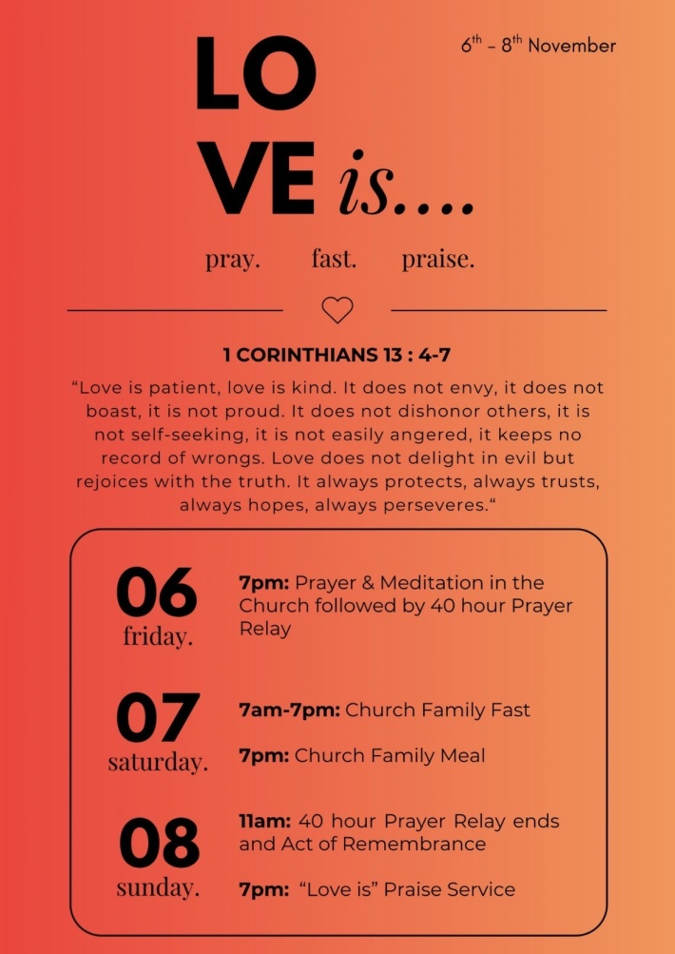
Find a quiet place free from distractions
Spend a few minutes in silence
Ask the Holy Spirit to speak to you
Open your heart to God
Read the passage and dwell on the verse in focus
Look up or listen to the song on your device
Use the prayer to shape your own prayers
Sustained by
the Word
Saturday
7th November 2026
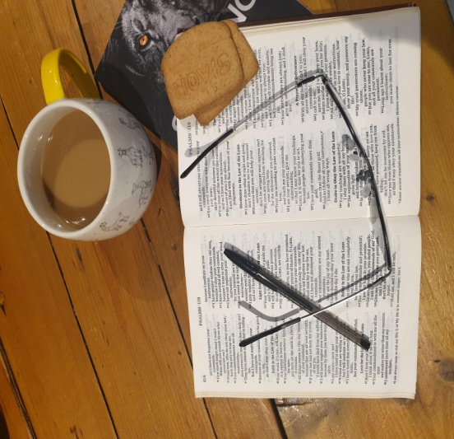

How sweet are your words to my taste,
sweeter than honey to my mouth!
Psalm 119:103

